**Technical Report - Database Project**

**1. Project Idea**

The project is an **online store** platform where customers can browse and purchase products. The system tracks customer details, orders, products, and order items using a structured relational database designed according to database course requirements.

**2. Entity and User Analysis**

**Main Entities:**

* Customers
* Orders
* Products
* Order Items

**Users of the system:**

* Admin (has full access to the database)
* Customer (can only view products and place orders)

**3. ERD and Mapping Design**

The ERD was designed with the following relationships:

* One customer can place many orders.
* One order can contain multiple items (OrderItems).
* Each item in an order is linked to a product.
* A product can appear in multiple orders.

**Entities and Attributes:**

**Customers**

* A diagram of a flowchart

  AI-generated content may be incorrect.customer_id (Primary Key)
* name
* address

**Orders**

* order_id (Primary Key)
* date
* shipping_address
* A diagram of a computer

  AI-generated content may be incorrect.customer_id (Foreign Key)

**Products**

* product_id (Primary Key)
* description
* price
* type

**OrderItems**

* item_id (Primary Key)
* order_id (Foreign Key)
* product_id (Foreign Key)
* quantity
* price
* discount

The names of entities and attributes were simplified for better readability and usability.

**4. Normalization**

The database schema has been normalized up to **Third Normal Form (3NF)**:

* No data redundancy.
* Every non-key attribute depends on the whole primary key.
* No transitive dependencies exist.

**5. SQL Code and User Permissions**

SQL statements were written to:

* Create all necessary tables with proper data types and keys.
* 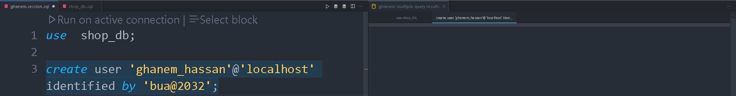Create user accounts and assign permissions:

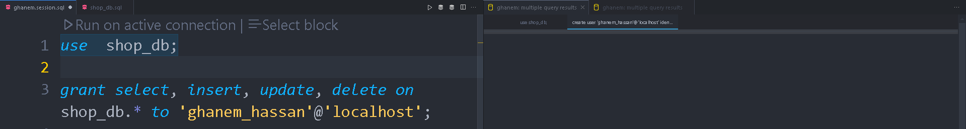 **6. Data Insertion**

Each table was populated with at least **15 records** using INSERT INTO statements to allow meaningful queries and testing.

**7. SQL Queries**

Five sample SQL queries were written, including:

* **Text Search (LIKE):  
  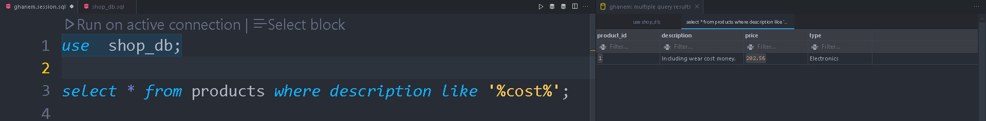**
* **Aggregate Function (AVG):  
  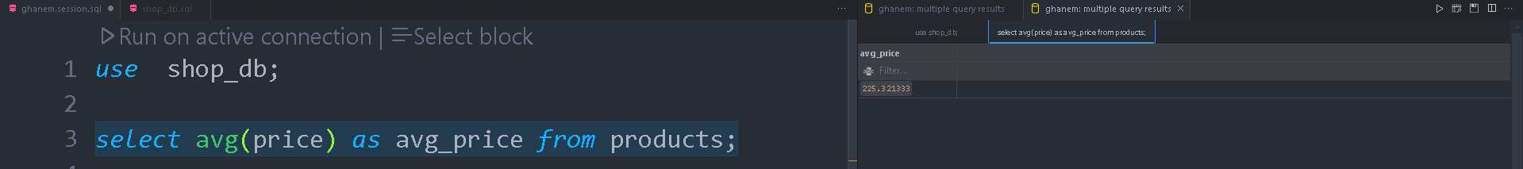**
* **COUNT (Grouped by Customer):**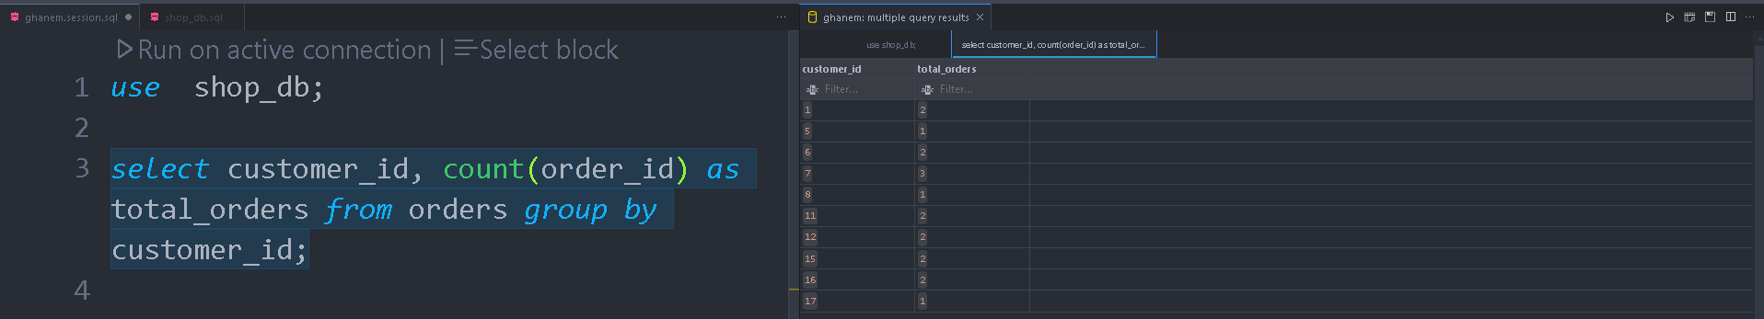
* **Descending Order by Date:** 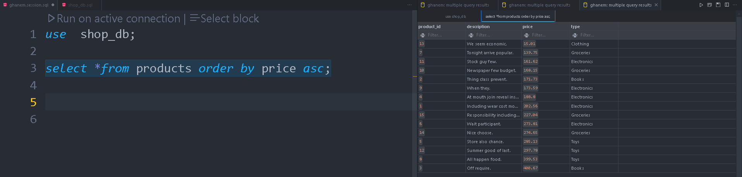
* **Join Products with Order Items:  
  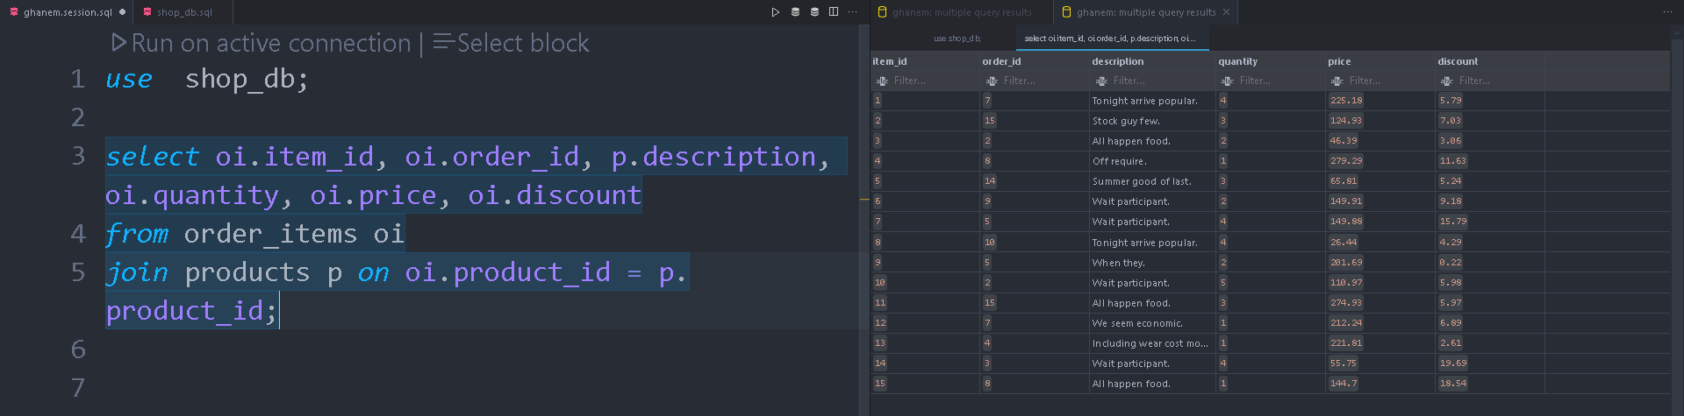**

**8. Conclusion**

The database project meets all technical and academic requirements including ERD design, normalization, table creation with SQL, data insertion, permissions, and query execution. The structure is scalable and adaptable for real-world e-commerce applications.